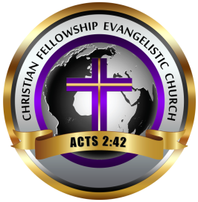

CFEC: SAY WHAT NOW???

**September 2024 [Vol 8]**

***Christian Fellowship Evangelistic Church, Inc is a house of worship for congregants, a beacon of hope and support for the community, and a safe haven for community members, the disenfranchised, and members of the congregation.***

**Message From Pastor Michael Kea**

Ah, patience! That delightful virtue often mistaken for mere waiting. But let’s be honest—patience is not about twiddling your thumbs or counting the seconds on a clock. It’s a joyful dance with life, a gentle reminder that good things truly come to those who wait!

As the Bible beautifully states in **James 1:2-4 (NIV)**: “Consider it pure joy, my brothers and sisters, whenever you face trials of many kinds, because you know that the testing of your faith produces perseverance. Let perseverance finish its work so that you may be mature and complete, not lacking anything.” This scripture reminds us that patience is not just a passive state but an active process of growth and maturity.

Imagine planting a seed. You don’t dig it up every day to see if it’s sprouted, do you? No! You nurture it, trust the process, and allow nature to work its magic. Life is much the same. Whether you’re pursuing a dream, building a relationship, or mastering a new skill, patience is your trusty companion.

So, let’s embrace patience with a hearty laugh! When things don’t go as planned, instead of fretting, chuckle at the unpredictability of life. With patience, you’ll discover that life’s sweetest rewards are worth the wait!

Much Love,

Pastor Mike

***SPOTLIGHT***

This month’s spotlight is on our Pastor, Michael Kea. This month, CFEC is celebrating the third anniversary of Pastor Kea in his capacity as senior pastor of Christian Fellowship Evangelistic Church. There have been many changes during the past three years. Ministries have been revamped, new ministries have been created, a new assistant pastor has been appointed, major renovations have been accomplished to the church building, there has been a growth in membership, new ties have been created between CFEC and the community it serves, and several new projects are being planned. Pastor Kea has been a blessing to CFEC in every sense of the word, and this month we acknowledge him and the numerous strides we have taken as a church under his tutelage.

**Pastor Michal Kea, Sr.** 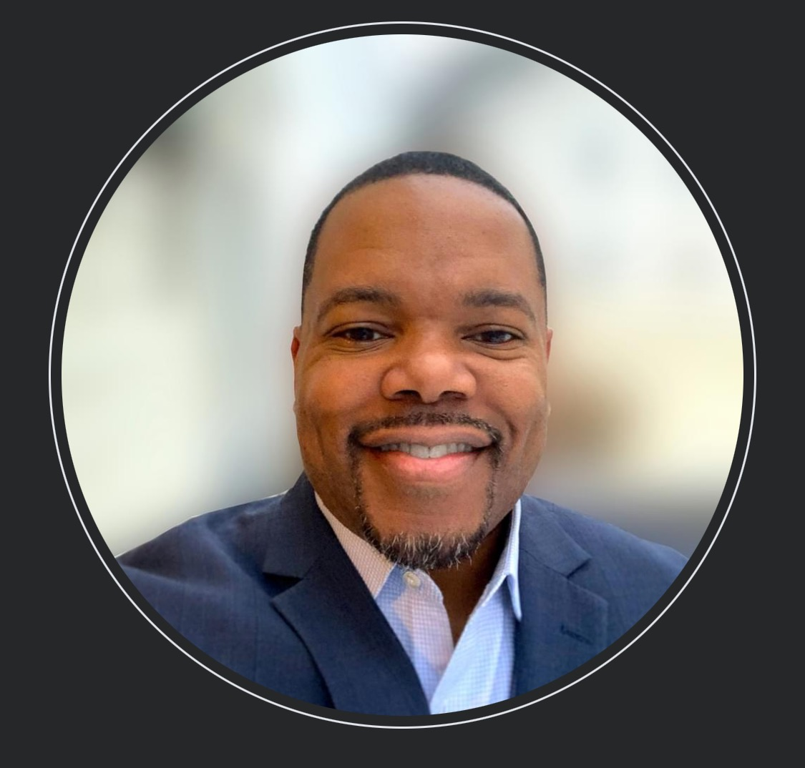

**SHEPHERD’S CARE COMMITMENT TO ENSURE THE NEEDS OF OUR PASTOR ARE MET**

Pastoral Care was started by our founder, Bishop Donald Outterbridge, Sr. His desire was that this ministry would take care of his needs, as our Senior Pastor. Pastoral Care was under the leadership of Mother Deborah Felder and included the members of our Deacon Board. Primarily, the responsibilities included making sure his office was clean, making sure he had his preferred snacks and beverages in his office refrigerator, keeping his robes clean, making sure any of his practical needs were met and planning his Pastoral anniversary.

As time went on, Bishop Outterbridge extended these services to our Asst. Pastor. It was at that time, the name of the ministry changed to Shepherd's Care, implying that the purpose of this ministry was to take care of those who are primarily responsible for the spiritual growth and development of the members.

This ministry continues under our current Sr. Pastor, Elder Michael Kea. While the above services are still provided to him, Shepherd's Care recently took on the responsibility of praying with our Pastor and Asst Pastor each Sunday, before they enter the pulpit. The members of Shepherd's Care understand that our Pastors have to deal with their own "life issues" and still come to church and deal with the membership per se. The purpose of praying with our Pastors is to help them re-focus on the task at hand. Our desire is to continue to serve our Pastors both naturally and spiritually and ensure there is nothing they need that we haven't fulfilled. [Submitted by Shepherd’s Care]

**TRIBUTE TO PASTOR KEA FROM PASTOR BOLDEN**

Pastor Kea: Transformative Leadership and Impact

Our church has experienced remarkable growth and renewal under the inspiring leadership of Pastor Kea. Since stepping into the role following the sudden passing of our founding pastor, Pastor Kea has made a profound impact on both our church and individual faith journeys. Here’s how:

Visionary Leadership- Pastor Kea has demonstrated exceptional visionary leadership, guiding our church through a period of significant spiritual and numerical growth. His ability to articulate a compelling vision has encouraged our congregation to aspire to greater heights in our faith journey and outreach efforts

Relatable and Approachable- One of Pastor Kea's most cherished qualities is his relatability. Despite his senior role, he remains approachable and down-to-earth, fostering a strong sense of community within our church. This accessibility has made it easier for members to connect with him and seek guidance, strengthening our collective bond.

Family-Oriented Ministry- As a dedicated family man, Pastor Kea places a strong emphasis on the importance of family in his ministry. His personal anecdotes and practical wisdom on balancing faith and family life have resonated deeply with many in our congregation, strengthening family ties within our church community.

Spiritual Insight- Pastor Kea's sermons are a testament to his spiritual insight. His messages are not only biblically grounded but also timely and relevant, addressing the specific needs of our congregation. This profound spiritual insight has enriched our collective faith and encouraged personal growth among members.

Church Growth and Impact- Under Pastor Kea's leadership, our church has seen impressive growth. We’ve expanded our ministries, increased our community outreach, and extended our influence beyond our local area. His emphasis on making an eternal impact has inspired us to be more active in both community service and global missions.

Through his visionary leadership, relatability, family focus, spiritual insight, and commitment to growth, Pastor Kea has truly transformed our church into a vibrant, impactful community of believers

**TRIBUTE TO PASTOR KEA FROM PASTOR OUTTERBRIDGE**

This last year under the leadership of Pastor Mike, Christian Fellowship has experienced growth spiritually and in our membership. Pastor Mike has also initiated some very innovative and practical things for our community. He’s the first pastor I’ve known to set up free Wi-Fi that’s available to our surrounding neighbors in our community, along with the implementation of S.H.A.P.E, that makes practical and useful information and resources available to us as members. Great job Pastor Mike!

**TRIBUTE TO PASTOR KEA FROM MINISTER LAKIA SMITH**

After losing Pastor Donald D. Outterbridge, Sr., the call for Pastor Michael Kea to take on the position of head pastor of CFEC was approached with what I can only imagine great angst and uncertainty. However, if that was his thought it very much so did not show! Though I know that his work as Pastor is nowhere near easy, his transition into leadership appeared effortless as he (what is commonly quoted) "Hit the ground running!"

Watching Pastor Mike effectively and diligently lead God’s people has been one of great honor to witness. Pastor Mike challenges not only himself, but the members to live and trust God for more in our endeavors and importantly in what we pray for “Now unto him who is able to do exceeding and abundantly above all that we ask or think, according to the power that worketh in us. (Ephesians 3:20 KJV)

Also, his ability to interact and connect with believers and non-believers no matter what age or topic, is one of the many qualities that he has that I believe keeps the members coming back or even logging onto Sunday service even if they are out of town.

For myself being not just a member but one of the ministers of CFEC, I am greatly honored and privileged to serve under his leadership. I’m learning from Pastor Mike how to be true and real not only to myself but most importantly to God and welcome stepping out of my comfort zone in various areas of my life and to do so even afraid.

Pastor Mike’s work as pastor/leader is indeed just beginning and is far from nearing an end. We are witnessing the beginning stage of his Pastoral ministry, and I strongly believe that if this is just the beginning stage, I wait in anticipation to see the greater works that he will do. The work that the Lord has for Pastor Mike to do is going to impact greatly not just his life, this church/community, but also the Kingdom of God. “Being confident of this, that he who began a good work in you will carry it on to completion until the day of Jesus Christ” (Philippians 1:6 NIV)

Congratulations to you Pastor Michael Kea, my friend/brother on your 3rd pastoral anniversary and surely many more to come. ***RECENT EVENTS*Pledge:** A few Sundays ago, Pastor Kea requested that every member of CFEC pledge a monthly amount towards the repayment of the CFEC reconstruction loan. There is no set amount, but rather it (donation) is according to what someone has in their heart to give. This pledge is not a substitute for tithes, but rather in addition to tithes. Thank you for giving from your heart!

**Baptism:** On Sunday, August 25th, eight members of CFEC publicly declared their commitment to Christ and spiritual renewal by being baptized. The names of these members are Wesley Cobbs, Jeremiah McAllister, Christian Quiller, Brandy Williams, Brandon Williams, Val-sharee Williams, Al Cordery Jr., and Albert Cordery III. Our entire congregation is excited for them and proud of the commitment they just made.

***UPCOMING EVENTS***

**September 6, 2024**: Pastor Kea’s Birthday

**September 15, 2024:** Pastor Kea’s Third Pastoral Anniversary

**September 18, 2024:** Shape session conducted by Lysette Outterbridge on Human Resources

**September 21, 2024:** Pastor and Lady Kea’s wedding anniversary

**September 24, 2024:** 7 PM Men’s Bible Study

**September 25, 2024:** 7 pm Special Pastoral Teaching with Pastor Mike (Marriage Maintenance)

**[Unless otherwise specified, all classes, teachings, and meetings are conducted via Zoom]**

*\*\*\*We ask you to keep the following CFEC members in prayer: Deacon DeWanda Taylor, Sister Pamela Anderson, Sister Victoria Fisher, Sister Alfreda Williams, Sister Juanita Anderson, and Brother Michael Tucker, Sr* **\*\*\*Contributions to our newsletter are encouraged. If you would like to include something in *CFEC: Say What Now???* email your copy to [top1sg1@gmail.com](mailto:top1sg1@gmail.com) NLT the 20th of the month. Community events, accomplishments of members, etc. We would be pleased to publish all uplifting copy. If possible, please include a photo, your name, and a number where you can be reached with all copy. It takes a village to make *CFEC: Say What Now???* a success!**

**CFEC CONTACT INFO:**

CFEC, 2331 W. Clearfield Street, Philadelphia, PA 19132

Phone: (215)225-3090

Email address: [cfecministry@gmail.com](mailto:cfecministry@gmail.com)

Zoom: (ID) 810 964 3142 (PW) cfec2020

Web page: CFEC.church

Connect with CFEC (Text messages, etc.): (662)367-9273